NAMA : DEA PUSPITA

NPM : 20441119

PRODI : SI-C PAGI

MATKUL : PEM. WEB I (PRAKTIK)

KODE : B

Design website dengan menggunakan CSS agar tampilan lebih menarik

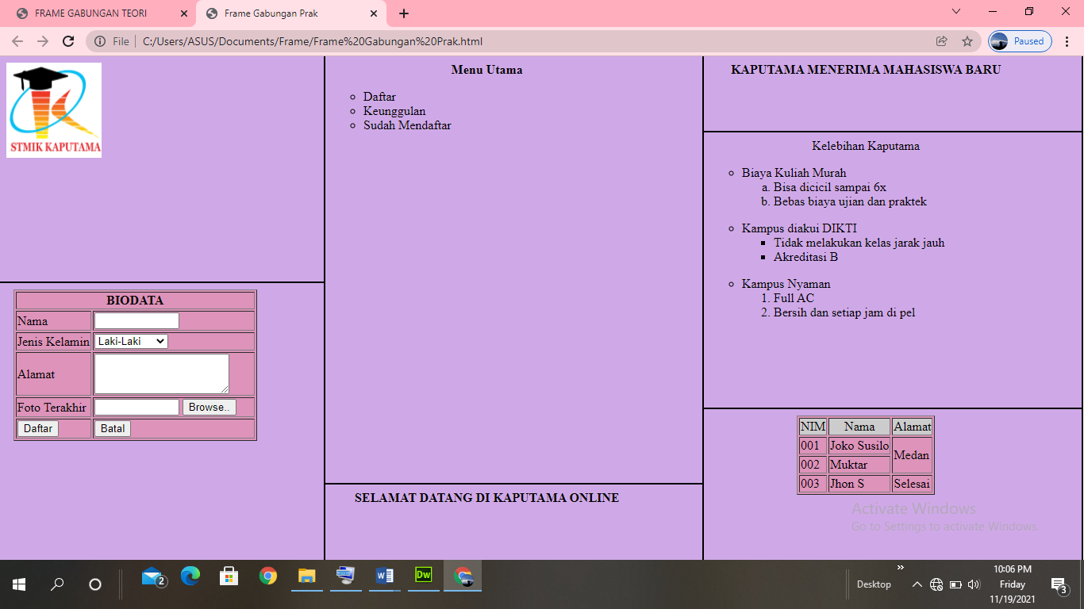

Di bawah ini adalah tag html untuk menampilkan website di atas, yaitu:

<!DOCTYPE html PUBLIC "-//W3C//DTD XHTML 1.0 Transitional//EN" "http://www.w3.org/TR/xhtml1/DTD/xhtml1-transitional.dtd">

<html xmlns="http://www.w3.org/1999/xhtml">

<head>

<meta http-equiv="Content-Type" content="text/html; charset=utf-8" />

<title>Frame Gabungan Prak</title>

<frameset cols="30%,70%,*" border="2" bordercolor="#000000">

<frameset rows="45%,*" border="2">

<frame name="atas" src="Gambar.html" noresize="noresize" />

<frame name="bawah" src="Biodata.html" noresize="noresize" />

</frameset><noframes></noframes>

<frameset cols="50%,50%" border="2" bordercolor="#000000">

<frameset rows="85%,*" border="2">

<frame name="atas" src="MenuUtama.html" noresize="noresize" />

<frame name="bawah" src="Welcome.html" noresize="noresize" />

</frameset>

<frameset rows="15%,55%,*" border="2">

<frame name="atas" src="judul.html"/>

<frame name="tengah" src="Kelebihan.html" noresize="noresize" />

<frame name="bawah" src="../Tabel1.html" noresize="noresize" />

</frameset>

</frameset>

</head>

<body>

</body>

</html>

* **Tag html untuk menampilkan gambar Kaputama**

<!DOCTYPE html PUBLIC "-//W3C//DTD XHTML 1.0 Transitional//EN" "http://www.w3.org/TR/xhtml1/DTD/xhtml1-transitional.dtd">

<html xmlns="http://www.w3.org/1999/xhtml">

<head>

<meta http-equiv="Content-Type" content="text/html; charset=utf-8" />

<title>Gambar</title>

</head>

<body>

<style type="text/css">

body

{

margin-left:1 cm;

margin-right:2cm;

margin-top:1 cm;

margin-bottom:1 cm;

background-color:#CFA9E7;

}

</style>

<img src="logo kaputama.png" height="120" width="120" />

</body>

</html>

* **Tag html untuk menampilkan bacaan “KAPUTAMA MENERIMA MAHASISWA BARU”**

<!DOCTYPE html PUBLIC "-//W3C//DTD XHTML 1.0 Transitional//EN" "http://www.w3.org/TR/xhtml1/DTD/xhtml1-transitional.dtd">

<html xmlns="http://www.w3.org/1999/xhtml">

<head>

<meta http-equiv="Content-Type" content="text/html; charset=utf-8" />

<title>Judul atas</title>

</head>

<body>

<style type="text/css">

body

{

margin-left:1 cm;

margin-right:2cm;

margin-top:1 cm;

margin-bottom:1 cm;

background-color:#CFA9E7;

}

</style>

<b><center>KAPUTAMA MENERIMA MAHASISWA BARU</center></b>

</body>

</html>

* **Tag html untuk menampilkan “Menu Utama”**

<!DOCTYPE html PUBLIC "-//W3C//DTD XHTML 1.0 Transitional//EN" "http://www.w3.org/TR/xhtml1/DTD/xhtml1-transitional.dtd">

<html xmlns="http://www.w3.org/1999/xhtml">

<head>

<meta http-equiv="Content-Type" content="text/html; charset=utf-8" />

<title>Menu Utama</title>

</head>

<body>

<style type="text/css">

body

{

margin-left:1 cm;

margin-right:2cm;

margin-top:1 cm;

margin-bottom:1 cm;

background-color:#CFA9E7;

}

</style>

<b><center>Menu Utama</center></b>

<ul type="circle">

<li>Daftar</li>

<li>Keunggulan</li>

<li>Sudah Mendaftar</li>

</body>

</html>

* **Tag html untuk menampilkan “Kelebihan Kaputama”**

<!DOCTYPE html PUBLIC "-//W3C//DTD XHTML 1.0 Transitional//EN" "http://www.w3.org/TR/xhtml1/DTD/xhtml1-transitional.dtd">

<html xmlns="http://www.w3.org/1999/xhtml">

<head>

<meta http-equiv="Content-Type" content="text/html; charset=utf-8" />

<title>Untitled Document</title>

</head>

<body>

<style type="text/css">

body

{

margin-left:1 cm;

margin-right:2cm;

margin-top:1 cm;

margin-bottom:1 cm;

background-color:#CFA9E7;

}

</style>

<center> Kelebihan Kaputama </center>

<ul type="circle">

<li>Biaya Kuliah Murah</li>

<ol type="a">

<li>Bisa dicicil sampai 6x</li>

<li>Bebas biaya ujian dan praktek</li>

</ol></ul>

<ul type="circle">

<li>Kampus diakui DIKTI</li>

<ul type="square">

<li>Tidak melakukan kelas jarak jauh</li>

<li>Akreditasi B</li>

</ul></ul>

<ul type="circle">

<li>Kampus Nyaman</li>

<ol type="1">

<li>Full AC</li>

<li>Bersih dan setiap jam di pel</li>

</ol></ul>

</body>

</html>

* **Tag html untuk menampilkan “Biodata”**

<!DOCTYPE html PUBLIC "-//W3C//DTD XHTML 1.0 Transitional//EN" "http://www.w3.org/TR/xhtml1/DTD/xhtml1-transitional.dtd">

<html xmlns="http://www.w3.org/1999/xhtml">

<head>

<meta http-equiv="Content-Type" content="text/html; charset=utf-8" />

<title>Biodata</title>

</head>

<body>

<style type="text/css">

body

{

margin-left:1 cm;

margin-right:2cm;

margin-top:1 cm;

margin-bottom:1 cm;

background-color:#CFA9E7;

}

</style>

<center>

<table border="1" bgcolor="#DD93BA">

<tr>

<td colspan="2" align="center"><b>BIODATA</b></td></tr>

<tr>

<td>Nama</td>

<td width="200"><input type="text" name="nama" size="10"/></td>

</tr>

<tr>

<td>Jenis Kelamin</td>

<td><select name="jk" size="1">

<option value="Laki-Laki">Laki-Laki</option>

<option value="Perempuan">Perempuan</option>

</tr>

<tr>

<td>Alamat</td>

<td><textarea name="alamat" cols="20" rows="3"></textarea></td>

</tr>

<tr>

<td>Foto Terakhir</td>

<td>

<input type="text" name="Foto Terakhir" size="10"/>

<input type="Submit" value="Browse.." size="5"/></td>

</tr>

<tr>

<td> <input type="Submit"

name="Submit" value="Daftar"/>

</td>

<td><input type="Reset" name="Reset"

value="Batal"/></td>

</tr>

</center>

</body>

</html>

* **Tag html untuk menampilkan “Tabel NIM, Nama, Alamat”**

<!DOCTYPE html PUBLIC "-//W3C//DTD XHTML 1.0 Transitional//EN" "http://www.w3.org/TR/xhtml1/DTD/xhtml1-transitional.dtd">

<html xmlns="http://www.w3.org/1999/xhtml">

<head>

<meta http-equiv="Content-Type" content="text/html; charset=utf-8" />

<title>Tabel</title>

</head>

<body>

<style type="text/css">

body

{

margin-left:1 cm;

margin-right:2cm;

margin-top:1 cm;

margin-bottom:1 cm;

background-color:#CFA9E7;

}

</style>

<center>

<tr>

<table border="1" bgcolor="#DD93BA">

<tr bgcolor="#CCCCCC">

<td align="center">NIM</td>

<td align="center">Nama</td>

<td align="center">Alamat</td>

</tr>

<tr>

<td>001</td>

<td>Joko Susilo</td>

<td rowspan="2"> Medan</td>

</tr>

<tr>

<td>002</td>

<td>Muktar</td>

</tr>

<tr>

<td>003</td>

<td>Jhon S</td>

<td>Selesai</td>

</tr>

</center>

</body>

</html>

* **Tag html untuk menampilkan bacaan “SELAMAT DATANG DI KAPUTAMA ONLINE”**

<!DOCTYPE html PUBLIC "-//W3C//DTD XHTML 1.0 Transitional//EN" "http://www.w3.org/TR/xhtml1/DTD/xhtml1-transitional.dtd">

<html xmlns="http://www.w3.org/1999/xhtml">

<head>

<meta http-equiv="Content-Type" content="text/html; charset=utf-8" />

<title>Welcome</title>

</head>

<body>

<style type="text/css">

body

{

margin-left:1 cm;

margin-right:2cm;

margin-top:1 cm;

margin-bottom:1 cm;

background-color:#CFA9E7;

}

</style>

<b><center>SELAMAT DATANG DI KAPUTAMA ONLINE</center></b>

</body>

</html>